V2 Verification
- All the strategy bets, need to be logged and available as part of analytics. The current ML prediction analytics are good but the average punter doesn’t cre, they should be the 3rd tab. They want to know THEIR own and just as importantly, THE Strategies analytical data, that way they can see if it is actually working and getting better. Let’s
- The Logo up the top needs to be changed  To this one  Available in docs betmatelogo\
- Few issues here 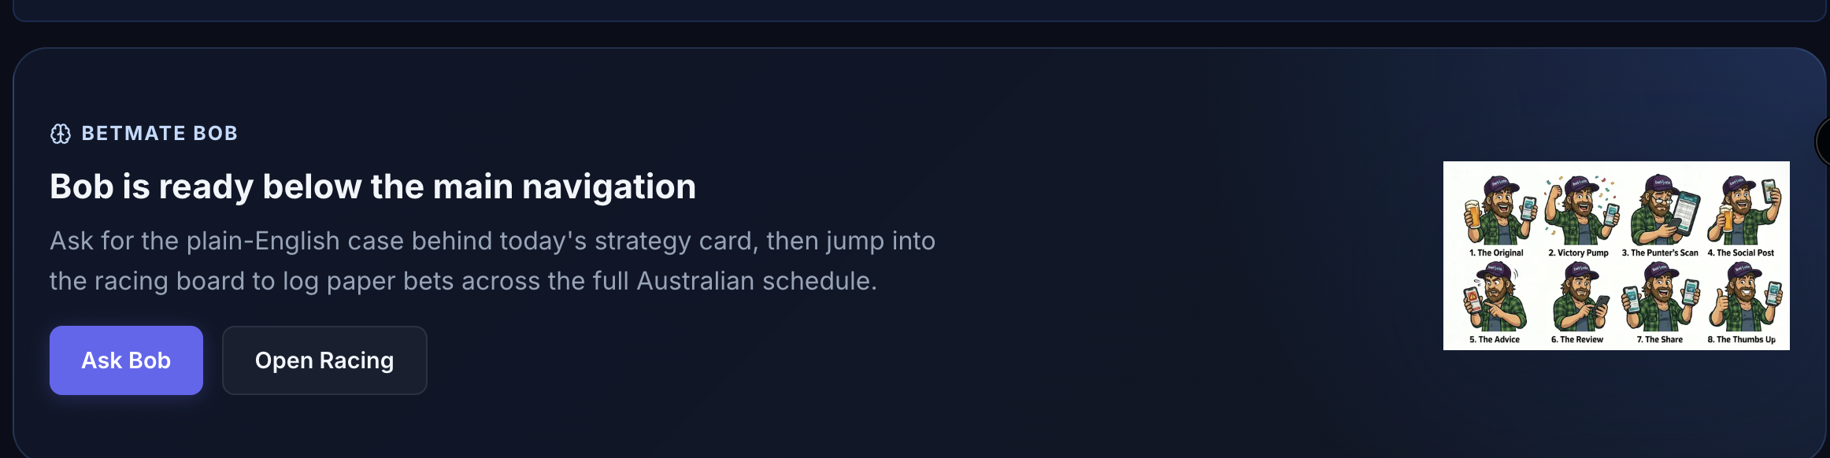It should just say ask bob – remove open racing. In fact everything can be removed except te Ask bob and image. Except the image will be above ask bob, and it will change to this one available under docs betmatebob logo – the whole thing should be at the bottom of the dashboard/main page. So im picturing somethings like this  with the image above it under all the predictions on the mai page, we can run something along it at a later date unless you have any thoughts?
- Blackbook completely unavailable 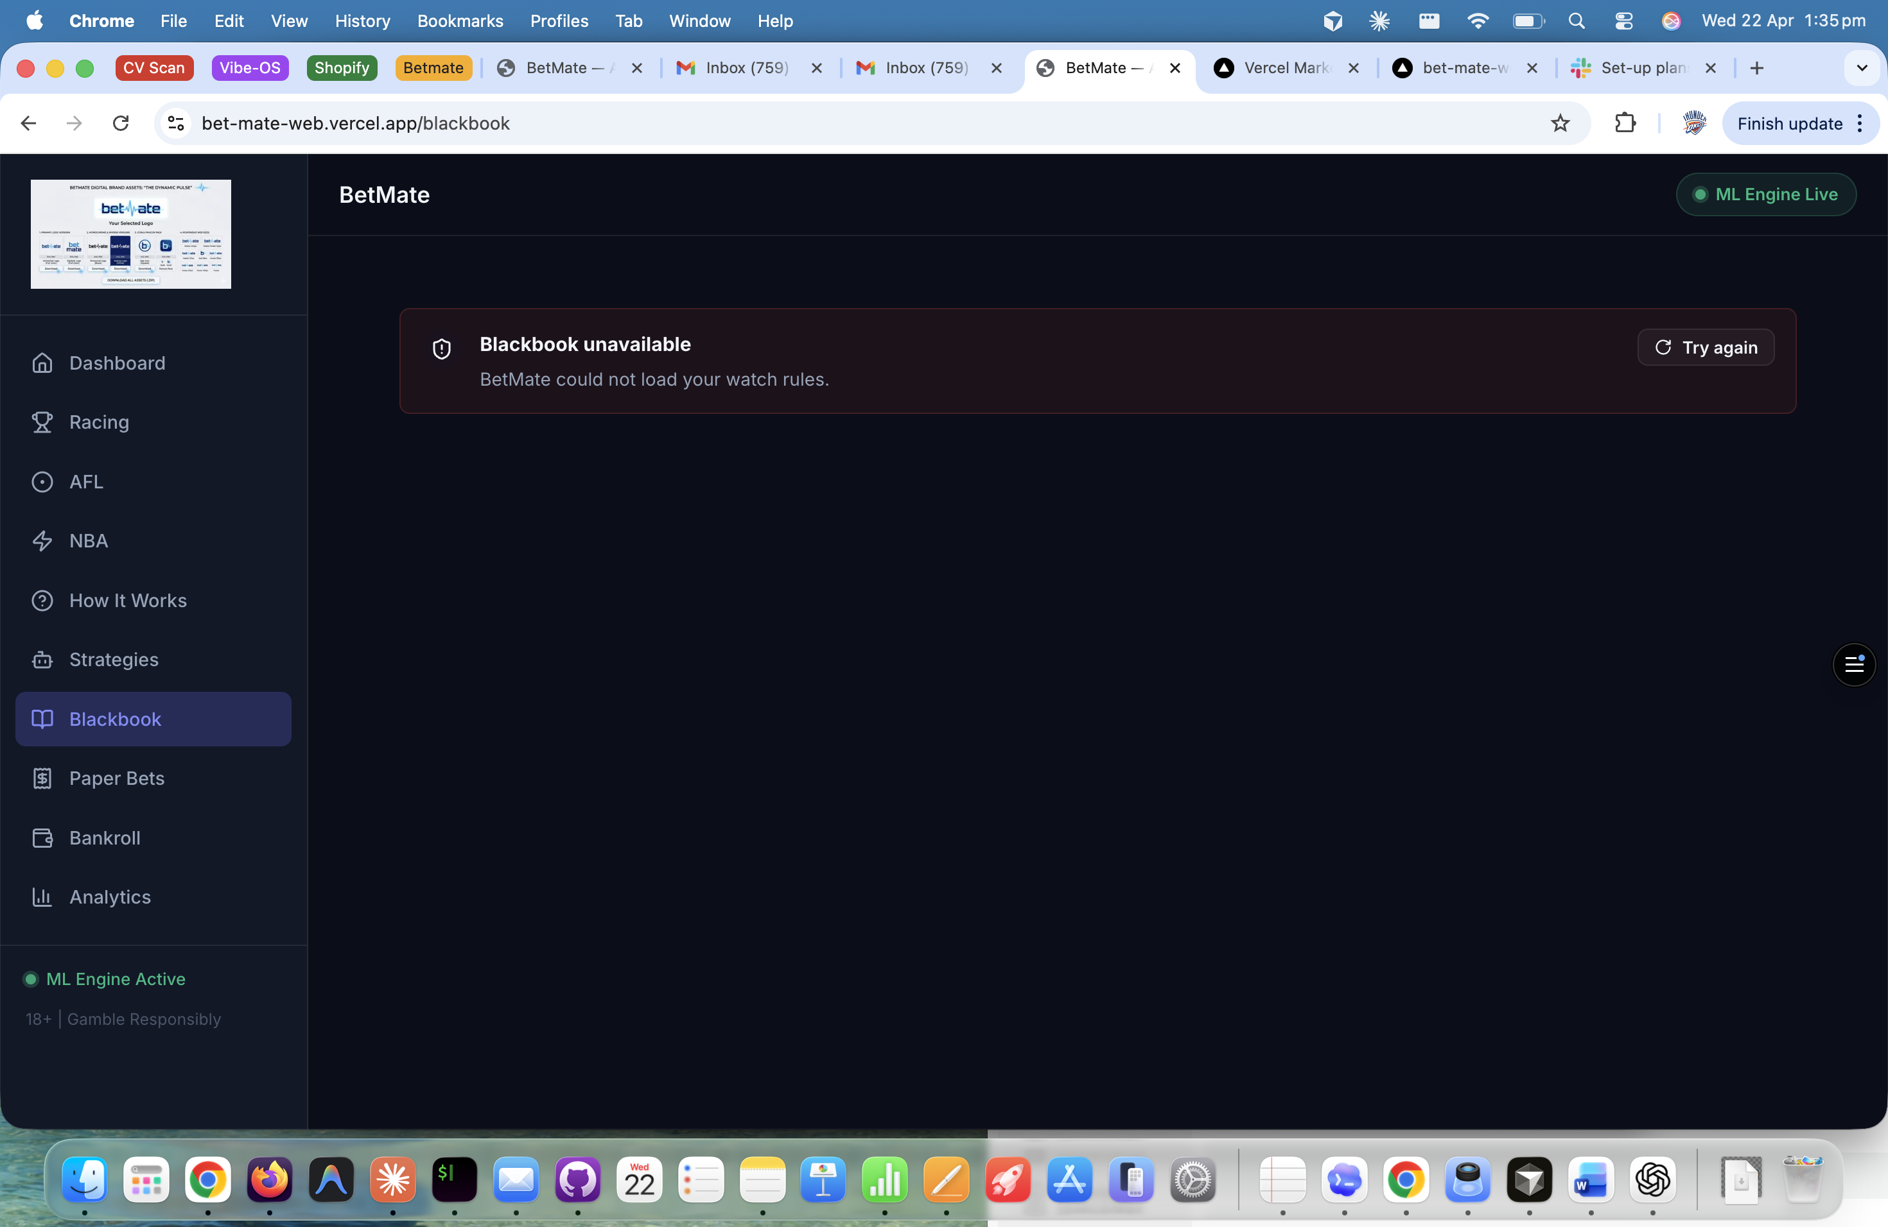
- Racing predictions unavailable – I want predictions on all main races Melb Syd everyday, O wed, fri, sat and other big days, some suday we want Bris and WA 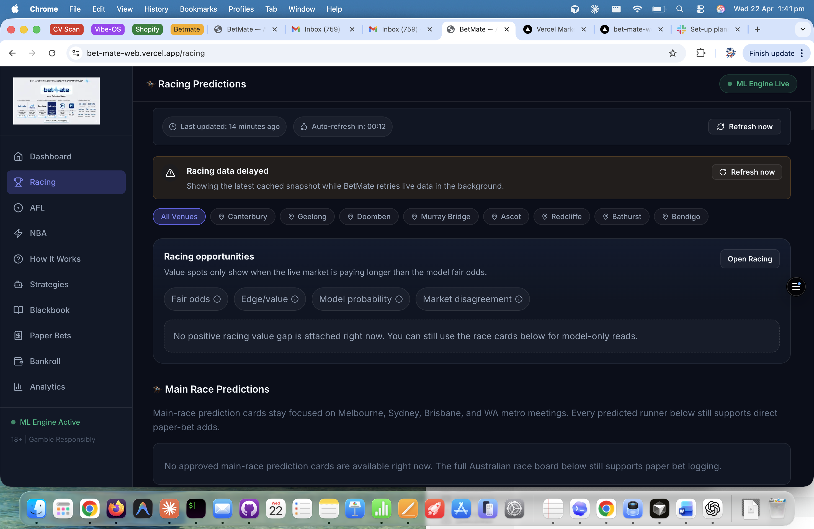The refresh isn’t working but assume cuz predictions aren’t there 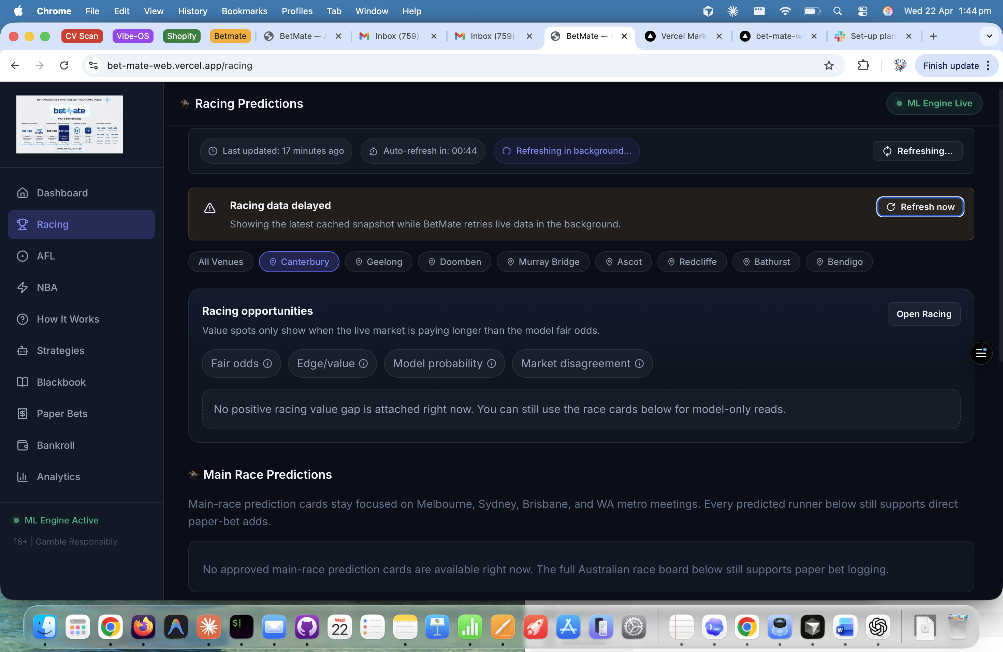
- Strategies – they aren’t loading which again I assuming is all the same problem betmate bob needs updating also 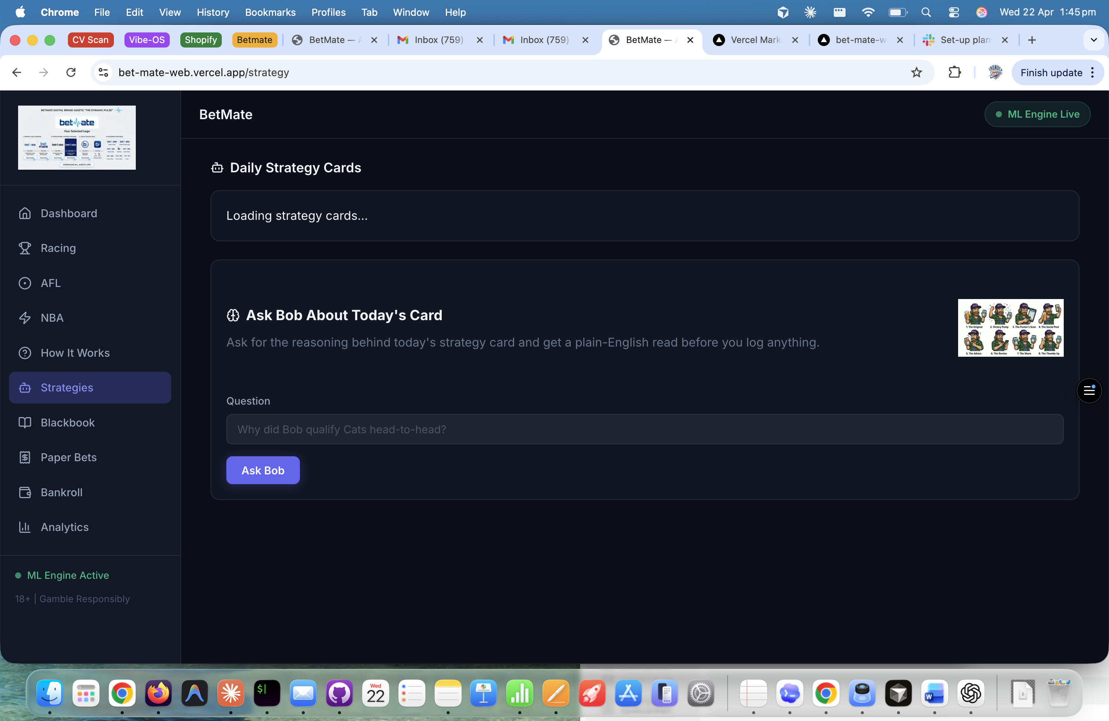
- Just change the name from paperbets to Bankroll and remove the current Bankroll all together
- After logging paper bets, they stay in the betslip, they log and then go away. Then I try log another afl home or aay an nothing happens, if I go to nba and click a team it brack all my old bets 